Creating an Assistive Technology Application to Aid the Treatment and Rehabilitation of Paediatric Facial Burns Patients

BSc Game Software Development

Katie Fisher

## Abstract

This project was undertaken to produce a piece of assistive technology for the rehabilitation of paediatric burns patients that meets the needs of all who would use it. The requirements of healthcare professionals, patient guardians and the patients themselves were assessed and evaluated. Research and testing were undertaken to establish the effectiveness of the deliverable, with positive preliminary results.

## Acknowledgements

I would like to thank my project mentor, Richard Mather for his support and guidance during this project. I would also like to thank my parents, Richard Fisher and Frances Fisher, as their medical knowledge has proved invaluable for guiding this research. My appreciation also extends to Dom Harris, who provided access to a wider variety of test subjects. I am similarly grateful to Brendan Mulvany for providing design inspiration.

Finally, I would like to thank Ivan Phelan whose continued work in assistive technology was the inspiration for this project.

# Contents

Abstract 2

Acknowledgements 3

Contents 3

1.0 Introduction 7

2.0 Background investigation 8

2.1 Paediatric Burns. 8

2.2 Physiological aspects. 8

2.3 Special paediatric considerations 9

3.0 What is Assistive Technology? 10

3.1 Existing products 10

4.0 Requirements 11

4.1 Medical professionals 11

4.2 patient guardian requirements 11

4.3 Patient Requirements 12

4.4 Requirement summary 12

5.0 Hardware 13

5.1 The Kinect 13

5.2 Generic Webcam 13

5.3 Arduino Uno 14

5.4 Hardware justification 14

6.0 Evaluating appropriate tools for the development process 15

6.1 Facial motion capture and detection libraries 15

1.1.1 The Microsoft Face Tracking Software Development Kit for Kinect for Windows (Face Tracking SDK) 15

1.1.2 OpenCV 15

1.1.3 Emgu 15

1.1.4 Affdex 16

6.2 programming languages 16

6.3 Programming Tools 16

6.4 Tools Conclusion 17

7.0 Development 18

7.1 Project Management Methodology 18

7.1.1 Waterfall method 18

7.1.2 Spiral Method 18

7.1.3 Agile Method 19

7.2 Methodology summary 19

7.3 Design Process 19

7.4 Formation of initial ideas 19

7.5 Creating the game 20

7.5.1 Controls 20

7.5.2 Game Scene 21

7.5.3 Game Objectives 22

7.6 Porting to other platforms 23

7.7 Changes 23

8.0 Testing 25

8.1 Primary testing stage 25

8.2 Secondary testing phase. 25

8.3 Secondary testing results 26

8.4 Ethical Issues 26

9.0 Evaluation 28

9.1 What has been delivered 28

9.2 Requirements met 28

9.2.1 Affordability requirement 28

9.2.2 Game Requirement 29

9.2.3 Simplicity of use requirement 29

9.2.4 Facial-control requirement 29

9.3 What needs to be improved 29

9.4 What Was learned from this project 30

9.5 Future Development 31

9.6 Conclusion 31

10.0 References 33

Appendix A 37

Appendix B 38

Consent Form 39

# Introduction

The aim of this project is to create a software package to aid the treatment and rehabilitation of paediatric burns patients. An investigation will be undertaken to assess the potential benefits of this deliverable. The research will focus on some issues surrounding paediatric burns and will be used to justify choices made during the development of the software. The needs of medical professionals, patient guardians and the patients themselves will be examined. This will be used to assess how the software can complement treatment and recovery.

Use of the term "the product" will refer to the software package. This product is intended to help young people during their recovery from a facial burns injury

# Background investigation

This chapter will cover the research undertaking at the start of the project. This research covers the nature of burn injuries and their effects on the target audience.

## Paediatric Burns.

Paediatric burns are a major injury affecting millions of children internationally. Almost a quarter of all burns victims are under the age of 16 (Krishnamoorthy, Ramaiah, and Bhananker, 2012). Large burn injuries can cause injuries to all major organ systems. Management of burn injuries can require aggressive surgical procedures to prevent sepsis and secondary complications. This is can be exceptionally painful, so pain management techniques are vital during this period.

## Physiological aspects.

The Oxford Medical Dictionary (2015) classifies a burn as "tissue damage caused by agents such as heat, cold, chemicals, electricity, ultra violet light or nuclear radiation".

Scars and contractures are a sequela of the majority of burns and also the resultant plastic surgery is undertaken in the recovery phase. In the case of facial burns, this complication can be disfiguring and significantly debilitating socially. It may also be physically debilitating as it can affect speech and normal feeding. Pain and pruritis (severe itching) can also be a long-term complication of scar tissue (Atiyeh B, Janom HH. 2014).

Thus, minimising contractures and scar tissue is very desirable, and it is accepted that this therapy is more successful the earlier it is undertaken in the recovery phase (Gu and Ohgi, 2013)(Procter, 2010). This project has been undertaken to help in the prevention of post-burn contractures by encouraging the patient to stretch and exercise their facial muscles. The focus will be on the mouth area as there is an emphasis on the importance of the quick recovery of the mouth during childhood development.

## Special paediatric considerations

Burn injuries are extremely painful, both at the time of the injury and during rehabilitation. This has an adverse effect on both the patient's psychological wellbeing and on the rate of the functional recovery process (Gu and Ohgi, 2013). Additionally, severe pain can cause a patient to fail to comply with treatment effectively. To manage this, therapeutic techniques based on play and games can reduce pain and improve function in children more effectively than rote exercise (Gu and Ohgi, 2013). Elevated psychological risks are of concern for paediatric patients, as a facial burn injury can affect a child's sense of identity, as developing children are coping with their emerging concept of self (Kung and Gosain, 2008, Gu and Ohgi, 2013).

# What is Assistive Technology?

Assistive technology is "any item, piece of equipment, or product system, whether acquired commercially, modified, or customised, that is used to increase, maintain, or improve functional capabilities of individuals with disabilities." (Specialised Knowledge and Skills in Technology and Environmental Interventions for Occupational Therapy Practice, 2010).

Examples of assistive technology include hearing aids, wheelchairs and prosthetic limbs. In recent years, video games have become a very exciting avenue for assistive technology. They have been investigated for their ability to rehabilitate stroke victims (Rand et al., 2014), to aid the speech development of autistic children (Rahman et al., 2011) and even to rehabilitate burn patients (Parry et al., 2014). There have also been many studies into their ability to reduce pain in patients (Sil et al., 2012)(Wohlheiter and Dahlquist, 2012).

## Existing products

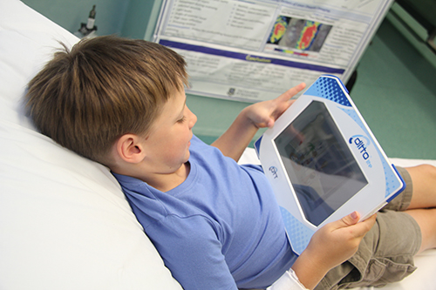No examples of assistive technology that focused on paediatric facial burns victims were found during the development of this project. However, examples of assistive technology focusing on more generalised burn injuries were found. The multi-modal distraction (MMD) device is a simple, handheld interactive device. The MMD device uses custom software that informs the child about the procedure they are about to undergo, and is intended to distract the child during dressing changes (Miller et al., 2010). It has been shown to significantly relieve the pain reported by paediatric burns patients. It is not designed to encourage physical movement to prevent contractures during recovery. Diversionary Therapy Technologies, creators of the ditto™ MMD device, market their product not only as a medically useful therapeutic gadget, but as a cost effective one compared with traditional distraction techniques (Diversionary Therapy Technologies, 2017). This suggests an incentive to make assistive technology affordable for medical professionals.

A child using the ditto MMD device (http://dtt.net.au/wp-content/uploads/2014/04/IMG_01481.jpg, 2017)

# Requirements

This section covers what people who would be using the product would require from it to be of use to them. This was researched via a combination of direct interview and reading journal articles.

## Medical professionals

Felicity Wordie (Wordie, F 2016), a band six occupational therapist at Weston General Hospital states that budget and accessibility are the major factors considered when adopting a new piece of assistive technology. She does, however, go on to say that when a new piece of assistive technology's accessibility is over-generalised in an attempt to cover as many therapeutic possibilities as possible, the usefulness of the assistive technology is decreased. To counter this, the product should be usable by as many people as possible while still performing a very specific function.

Once an initial prototype of the product was built, Mr. Hock Hoe Goh, consultant orthodontist and Mr Nick Brown, maxillofacial surgeon, both of York & Scarborough Hospital, were interviewed about their respective professional opinions of it. Mr. Goh (Goh and Brown, 2017) stated with the agreement of Mr. Brown, "It is certainly applicable to burns victims, and maybe to patients who have suffered damage to their facial nerve which supplies movement to the muscles of facial expression". They also expressed a desire to see a component added that would encourage a child to smile or laugh, to further encourage the movement of the muscles of facial expression.

After further research, cost-effectiveness was found to be an area of high scrutiny in the medical field (Siegel, 1987) (Kumar, 2011).

## patient guardian requirements

The primary requirement for patient guardians is the cost accessibility of the product. A product that a patient guardian cannot acquire because of excessive cost is useless to their dependant.

## Patient Requirements

The most important requirement for the patient is that it aids their recovery. The patient must be able to understand how to use the product. It has been shown that control systems with high degrees of complexity may cause problems for players who lack manual dexterity, including children or people with motor impairments (Said and Kane, 2013).

## Requirement summary

The needs of all user groups were considered and a list of requirements was created. Both medical professionals and patient guardians expressed that affordability was very important. The product should encourage the use of the patient’s facial muscles, particularly those of the mouth. Moreover, the initial research phase suggested presenting the product in the form of a game would be beneficial to the patient group. It was shown that playing games reduced pain during different medical treatments. The final major requirement was accessibility. Patients should be able to understand how to use the software. For these reasons, the requirement list for the product is as follows:

* The product must be affordable
* The product must be presented in the form of a game
* The product must be simple enough for patients to use
* The product must encourage the movement of the patient’s facial muscles, with focus on the mouth.

During development, the product package will be assessed with respect to this requirement list.

# Hardware

This chapter covers the hardware that was reviewed for use with the product. Since the product is based on facial movement, it was decided early on that camera-based device would be used. Additionally, a device for running the product would be required.

## The Kinect

The Kinect is a line of motion sensing input devices created by Microsoft. Primarily used to play games on an Xbox 360 or Xbox One unit, they can also be connected to a Windows PC using an additional adapter. Upon testing, it was found that The Kinect is a very precise input method for facial capture, with the ability to work in both 3D and 2D. Microsoft also provides an SDK for facial tracking for use with the Kinect.

The Kinect unit itself is somewhat expensive to acquire, costing £79.99 directly from Microsoft. Should a patient already own or have access to this hardware, an adapter is still necessary to work with a Windows PC, which costs £29.99 directly from Microsoft. The Kinect's prohibitive cost to acquire and lack of use outside a windows environment means it is not very suitable for meeting the product requirements.

## Generic Webcam

A webcam is a video camera that streams images to a computer or network in real time. Webcams are relatively cheap and easy to acquire, as they can be found at major supermarket chains or online for under £10. Furthermore, many common home computing devices such as laptops or tablets are built with webcams pre-installed. Upon testing, they provided far fewer features than The Kinect camera, such as depth sensing, but were perfectly adequate for use in this instance. They can be used across a variety of devices and operating systems. Their low cost and ease of access are well suited to achieve the product requirements.

## Arduino Uno

The Arduino Uno is an open-source microcontroller board. It is modular, which allows the connection of input or output devices to perform actions. Cameras are one such module that can be attached. The Arduino is very simple to program, and its modular nature allows for interesting combinations of input and output devices that could assist with creating software for patients that cannot effectively use standard setups. A patient who needs to close their eyes or is partially sighted that may struggle with a Graphical User Interface (GUI), could be able to play a sound-based game using an Arduino connected to a buzzer or speaker.

They are low-cost boards, but their pin-based connector system can be easily damaged, possibly making them unsuitable for young children. Protective housing and modules come at an additional cost, and all require assembly.

## Hardware justification

Accounting for cost, ease of use and availability, the generic webcam seems to fit the requirements of the project the best. In a survey by the Office for National Statistics (2014), 85% of UK households contained at least one personal home computer. For the ones that don't already have inbuilt webcams, a cheap USB webcam would be the easiest and cheapest of the given options to acquire and set up. Also, it has been reported that 71% of children had access to a tablet at home (Ofcom, 2015). Among 18-44-year-olds, the group mostly likely to have children under 10 (Ons.gov.uk, 2014), 91% own smartphones (Deloitte, 2016). Given the ubiquitous nature of these devices, the product should be easily adaptable to work on as many of these devices as possible to achieve maximum accessibility for paediatric patients. A webcam-based application could be easily converted for use with a smartphone or tablet camera.

# Evaluating appropriate tools for the development process

This chapter will review the available tools and will elaborate on the reasons for choosing to work with them.

## Facial motion capture and detection libraries

This section will focus on and detail the range of libraries studied that deal with facial capture and tracking.



### The Microsoft Face Tracking Software Development Kit for Kinect for Windows (Face Tracking SDK)

Released by Microsoft, this package is designed to work with the Kinect, so the Kinect for Windows SDK must be installed for use.

This SDK can track faces and deduce facial expressions.

(Msdn.microsoft.com, 2012)

### OpenCV

Developed by Intel, OpenCV is a library chiefly aimed at real-time computer vision. It is written in C++ and its primary interface is also C++, but wrappers in other languages such as C# have been developed. Although it is a very powerful set of tools, it can be difficult to work with. It can be used to detect and recognise human faces and emotions but has many applications beyond that.

(Opencv.org, 2017)

### Emgu

Emgu is a wrapper for OpenCV. It allows OpenCV functions to be called from .NET compatible languages such as C#, Visual Basic and IronPython (Emgu.com, n.d.). After initial setup in Visual Studio, it can quickly be used for face detection. The documentation was found to be poor and outdated, specifically for Unity integration.

(Emgu.com, n.d.). Initial tests yielded a poor framerate, not desirable when working with game software.

### Affdex

Developed by Affectiva, the Affdex SDK has been developed for a variety of different platforms and includes Unity integration. The Affdex SDK was creation specifically for emotion recognition, so can begin tracking facial features after a short amount of setup.

(affectiva.com, 2017)

## programming languages

OpenCV's primary interface is C++, but wrappers exist to make it available in other languages. Microsoft's Face Tracking SDK can utilise both C++ and C#, and as a plugin for Unity, Affdex is written in C#. IronPython and Java were also explored for their ability to be used with OpenCV wrappers.

## Programming Tools

Two development platforms were considered for this project. The first was Visual Studio, a Microsoft developer tool with built-in support for C, C++, VB.NET, C# and F#. It also supports a multitude of other languages via separately installed packages. The second tool to be considered was Unity, a cross-platform game engine developed by Unity Technologies. The main draws for Unity include its editor interface, and its ability to target a multitude of platforms incredibly easily. The editor interface is well suited to games development because the scene and game views allow developers to visualise the game in even when a build is not running. Additionally, many processes such as asset workflow are hugely simplified by the editor's drag-and-drop features.

## Tools Conclusion

After evaluating the numerous tools, languages and libraries on offer, it became apparent that using Affdex in the Unity engine would best meet the requirements of this project. While the Kinect software is powerful, it is limited by its reliance on the prohibitively expensive Kinect hardware. It would also be limited to far fewer potential platforms than an application created with the Affdex for Unity SDK.

OpenCV has an excellent facial recognition and detection system, but Affdex requires far less setup time. While there is an OpenCV package for Unity, it was not tested during this project due to its excessive cost. Unity was chosen over Visual Studio for a number of reasons. Unity offers a faster set-up time as well as its editor interface, and crucially offers the ability to target more platforms easily, making it a more useful tool for this project.

# Development

This chapter will detail the development of the project. Design ideas, difficulties, initial tests and changes will be covered.

## Project Management Methodology

Several development methodologies were researched and considered for this project. This section will cover what was learned and why one was chosen.

### Waterfall method

The Waterfall method is "a development method that is linear and sequential." (Rouse, 2007).

The benefit of following Waterfall methodology is that each stage of the product lifecycle does not overlap with another, this removes any confusion and dependencies on other stages. Waterfall method works well for smaller projects with few requirements

The main drawback in the use of Waterfall is a restrictively linear workflow. Once a product is in the testing stage, changes cannot be made. Another disadvantage is that if the deliverable/ project itself has changed, the model does not allow for those changes This makes Waterfall unsuitable for projects where the chance of change is high

(Istqbexamcertification.com, 2017).



### Spiral Method

Spiral method is similar to Waterfall method, but more emphasis is placed on risk analysis.

It is well suited to large and important projects, as the risk analysis phase enhances risk avoidance.

It is considered unsuitable for smaller projects because the heavy documentation and level of work involved with risk avoidance is time consuming.

(Istqbexamcertification.com, 2017).

### Agile Method

The Agile method is an iterative process where a project is expected to change and adapt during the development process. Once a build has been produced, the users can test it and provide feedback. This feedback can be accommodated in the next iteration of the build. If target deadlines for iterations are not met, a Sprint is initiated where a goal is worked towards for a fixed time.

The downside of the Agile method is the difficulty involved in estimating the effort and time required at the start of projects. This is especially true of large projects.

(Istqbexamcertification.com ,2017)

## Methodology summary

It was decided that the Agile development method would be undertaken for this project. The Agile methodology gives more flexibility as it allows for changes in response to expert feedback. Given the amount of new research necessary for this project, it was considered that the requirements were at high risk of change during development.

## Design Process

Despite moving through several design iterations, conceptually the product has remained relatively static. The background research and interactions with medical professionals resulted in very positive feedback on the core concept, meaning it did not undergo any serious upheaval.

## Formation of initial ideas

The initial investigation showed that presenting this assistive technology in the form of a game would have several benefits. The reduction of pain and the potential increase of compliance in paediatric patients were the main motivations behind the decision to create a game-based application.

The initial investigation also showed there was an emphasis on facial movement, particularly of the mouth. For example, The Model Systems Knowledge Translation Center (MSKTC), a research centre focusing on spinal cord, traumatic brain and burn injuries, lists two sets of mouth stretches on its recommended exercise list for facial burns (Msktc.org, n.d.). Using this information, it was decided that a game controlled by opening and shutting the mouth would meet the requirements.

Knowing that this game must be accessible to young paediatric patients, it was established that the game mechanics used should be simple enough for a very young child to understand. Parents of were asked what kinds of games their children enjoyed playing (Appendix A). The responses were hugely varied, but the Mario series of games was referenced by parents with children of a range of ages. This range of data implies Mario is accessible to younger children, but still engaging enough to entertain older children.

To make the game as accessible as possible on a range of devices, it was decided that the game should utilise a simple control scheme, such as the one found in many games of the infinite runner (also known as endless runner) genre.

Jetpack Joyride (Halfbrick Studios, 2017) was found to be a particularly good example of this genre. Jetpack Joyride can be described as a simplified Super Mario Bros., adapted for a single-button interface (Rodgers, 2017). It achieved 14 million downloads on iOS platforms between its August 2011 release and February 2012 (Caoili, 2012), suggesting it’s a highly engaging game.

## Creating the game













### Controls

Given that burns result in a vulnerable skin injury, it is desirable that this project requires as little physical contact with the patient’s face as possible. Attempting to attach a control device to the face would result in severe pain and would also be a poetical hygiene risk. Therefore, a camera-based control system was deemed the most appropriate.

The product requirements specify the game must be simple enough for a child to play, so this control complexity barrier was taken into consideration.

In Jetpack Joyride, the player controls a character running along the ground. The player character’s speed is fixed in the X direction. Tapping anywhere on the screen activates the player’s jetpack, causing them to rise in the Y direction. Obstacles are dodged and items are collected by controlling the character’s vertical movement.

A control script was created that moved a gameobject in the positive X direction at a constant speed. A method was added to raise the gameobject on a mouse click. This provided the basic framework for the game controls.

The requirements of the project state the product should encourage the movement of the facial muscles, particularly the mouth. Affdex records “mouth open” as a value between 0 and 100, from closed to open respectively. This mouth open value can be used to control a Boolean value, by evaluating if the mouth open value is greater than or less than a threshold value. In this way, opening or closing the mouth can be analogous to a button press. Following this, the mouse click was replaced with the player’s mouth being opened.



### Game Scene

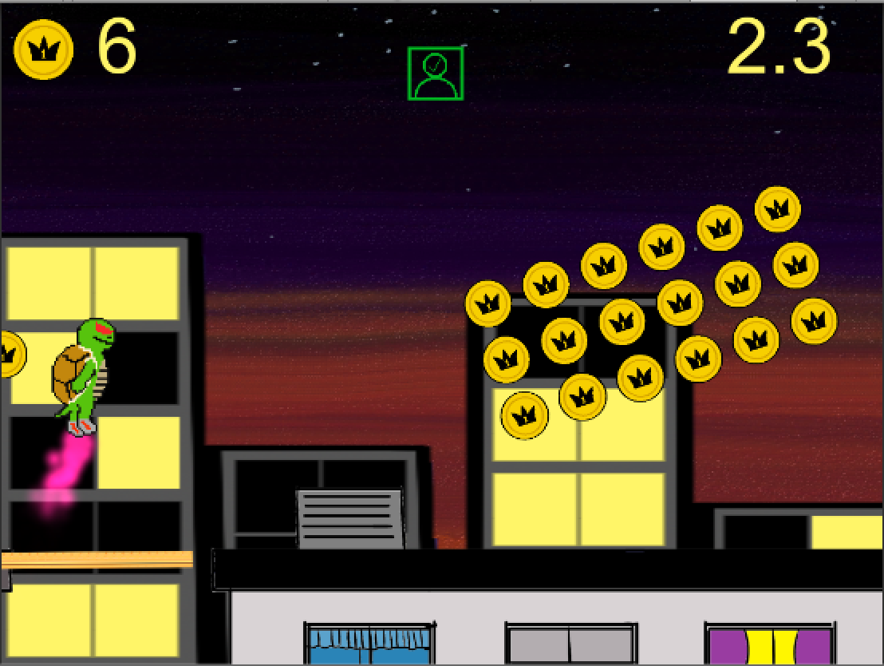Original designs for the product were created by the developer through a combination of Pixel Art Studio, Gimp and Fresh Paint. Designs for objects and scenery were given bold outlines to make them distinctive and easy to differentiate. The game was given a character for the player to control, as well as stationary and rotating objects to avoid. Coins were added to the scene give the player something to collect. Inspired by games of the infinite runner genre, the player moves from left to right on a 2D plane. This continues endlessly until an end condition is met. Prefab environments are loaded and destroyed off-screen to give the impression that the player is moving through an infinite level. 

### Game Objectives

The player can pick up coins which increase their score by one. A time limit is imposed that counts up to 20 seconds, at which point the game ends. The timer will only increment when the players mouth is registered as open. The 20 second time limit was chosen because MSKTC suggest that a therapeutic exercise be maintained for at least 20 seconds at a time (MSKTC, 2017).

In *Game Design Workshop*, Tracey Fullerton writes that “in addition to providing challenge, the objective of a game can set its tone” (Fullerton, 2008). The project is targeted at paediatric patients, who are sometimes very young or recovering from emotional trauma, it was decided that the main character of the game would not be injured or die as in any other infinite runners. This could be unpleasant or upsetting for a child or vulnerable person. Instead, the player score would decrease by 10 if the character collided with an obstacle. To reflect this in the design, the main character became a turtle, an animal associated with its strong defensive shell. In the Super Mario series of games, the Koopa enemies are-turtle like in design, and their shells cannot be destroyed.

The lack of a fail state in the game also allows for the game to continue for a given time. The product is first and foremost a piece of assistive technology, so the primary aim is for the player to exercise their facial muscles. It would be counterproductive for the game to end before the player has properly exercised their mouth.

## Porting to other platforms

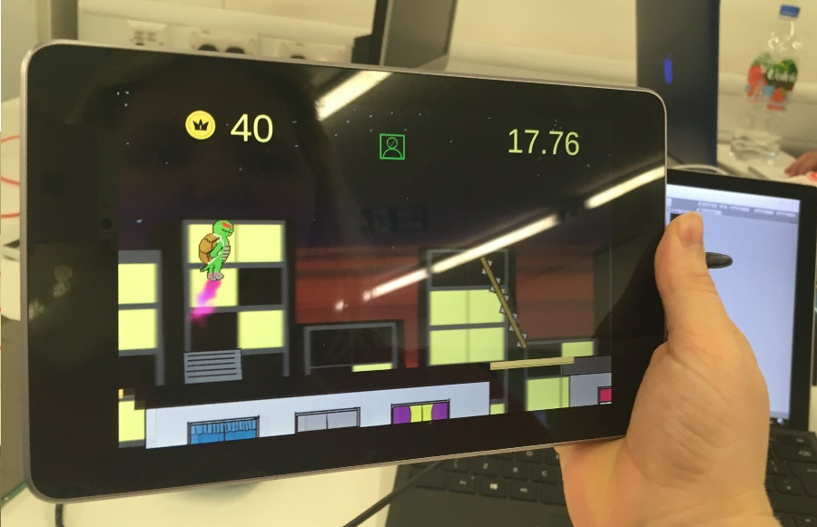Using the Unity SDK allowed for quick and easy porting to other platforms. The hardware justification noted that tablets and mobile devices were widely available, so it was desirable to ensure the product could be used on them. The tablet pictured on the left is a Google Nexus 7. It was deliberately chosen because its hardware specifications are significantly lower powered than the personal computers used to create the product. The main PC used in development runs on 2.4-GHz Intel Core i5 processor, whereas the Nexus 7 runs on a  1.2 GHz Cortex-A9 ARM processor.

The Affdex Unity SDK advises a minimum processor speed of 2.0GHz, which means the Nexus 7 is below the recommended requirements. Despite this, the game was still functional and facial detection worked, although there was a noticeably higher incidence of the software losing the face.

## Changes

The first major change to happen was the move away from a Kinect-based project to a webcam-based one. The positive and negative reasons for using each one were weighed against each other, and it was decided that a webcam-based system would be vastly more affordable while remaining functional.

The initial build of the game was received well by the children who played it. Comments included "it's fun to play" and "I like the turtle". After the comments from Mr. Hock Hoe Goh and Mr Nick Brown in section 5.1, an additional game mode was created that incorporated scatological humour. Given the importance of the exercises the product is designed to assist with, additional art was made for a mode not reliant on facial capture. This is intended to provide a backup in cases where facial capture would be hindered. This could happen in environments with insufficient lighting, for example.

# Testing

This section will detail the methods of testing undertaken, as well as justifying the importance of each stage of testing.

## Primary testing stage

The developer and acquaintances of the developer routinely tested the software for bugs in the software design. This stage is important for creating a product that works as it should under repeatable conditions. The next stage of the testing process will focus on human interaction with the software, so it is crucial to discern the difference between broken software and software that is not accounting for human variation. This was undertaken successfully.

## Secondary testing phase.

This stage of testing attempts to demonstrate the software will work properly with as wide a range of people as possible.

Problems have occurred in software development when a gendered or racially homogenous team of developers fails to account for users who do not fit their experiences. This can be a particular problem with camera-based software. Andy Trowers, a developer at Zoë Mode discovered his game had problems detecting dark skinned people just before launch. With no time to fully fix the issue, the game was shipped while still failing to detect black players properly. Trowers stated “It shows the lack of diversity in the industry that no-one noticed the game struggled to work with black people until the very end” (Trowers, 2017). Google has also had issues with their software failing to detect black users (Mulshine, 2017).

To avoid this, testing was done to ensure the software could be played by a wide range of people. Since the software is aimed specifically at paediatric patients, efforts were made to test the software on people under 16, as well as on adults. People of different races were sought out to help with testing, to ensure it would work properly. In addition to this, test subjects who wore and did not wear glasses were sought out.

Facial detection was not the only reason for having a wide variety of test subjects. The requirements of the project state the product must be simple enough for children to understand.

## Secondary testing results

A sample of people were asked to play the Jet Turtle game (Appendix B), and the game was checked to ensure it detected their faces correctly.

The software successfully detected all the people tested.

Positive feedback was given by several of the children who took part. Jess, Abby and Nona commented positively on the gameplay, as well as the design.

Shivam, one of the children who tested the game, could not speak English. This made communicating instructions difficult. His guardian was able to speak English and relayed the instructions to him. Shivam understood what to do once his guardian explained.

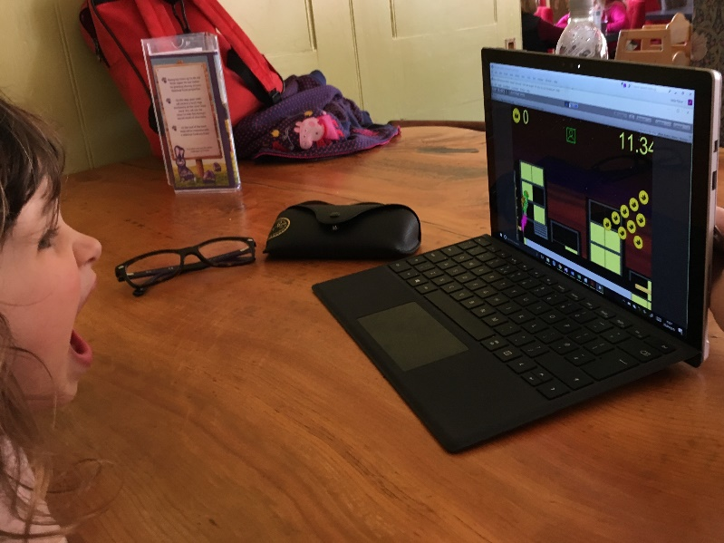Evie, the youngest of the testing participants at 3 years old is pictured here (figure 1). She responded very positively to the game and requested to keep playing once the testing had finished.

The most substantial testing issue found concerned particularly young participants covering portions of their face with their hands. This resulted in the software failing to capture the face properly. This behaviour was clearly due to shyness, but the attending guardians encouraged them not to do this, entirely unprompted.

Figure 2: Evie playing Jet Turtle

## Ethical Issues

A consent form was provided to each participant, or in cases where the participant was under 18, a consent form was provided to their guardian. The game was designed to cause as little distress or anxiety as possible. The game was tested on healthy adults and children only, due to the difficulty in overcoming the ethical considerations of testing on paediatric burns patients.

# Evaluation

This chapter will examine the project with regards to what has and has not been achieved by the deliverable.

The goal of this project was to create an assistive software application for paediatric burns patients. An assessment of the needs of medical professionals, parents and the patients themselves was done to make the product effective.

## What has been delivered

The final deliverable is a software package built in Unity and programmed in C#. It uses the Affdex Unity SDK to capture streamed video from a webcam, and turn it into the input method for games. The player's mouth is the focus of the control system, and they must stretch it open and closed to play the games.

The software is reasonably responsive, although there is a small amount of lag between player action and game response. Additionally, lighting conditions must be considered when the games are being played.

More than one face-controlled game was included to demonstrate the versatility of the gameplay types that can be achieved with the facial-control scheme. Versatility of gameplay types was not a requirement of the original project, but this was incorporated into the deliverable because it shows the concept is not tied to original core Jet Turtle game. Providing more than one game to play may also increase the interest and enjoyment for the child.

## Requirements met

After the initial investigation, a list of requirements was drawn up that attempted to meet the needs of the target audiences of the product. This section will evaluate if these requirements were met.



### Affordability requirement

Considerations were made for the cost of use of the product. The Kinect hardware approach, while performing excellently from a software point of view, required overly expensive hardware to use. It was abandoned in favour of the generic webcam approach. This meant a massive reduction in hardware costs. Personal computers and smart devices was also researched, showing that a huge majority of the target audience would have access to these devices at home. Producing an application for these ubiquitous devices is more cost-effective for the end user than producing a custom combination of hardware and software, such as with the Arduino. The developer therefore considers the cost requirement to be met.



### Game Requirement

The product contained multiple games.

### Simplicity of use requirement

The games have simple control schemes and gameplay concepts.

### Facial-control requirement

The games’ control schemes use the captured facial movement data of the player.

## What needs to be improved

Due to the ethical complications, it was not possible to test this software on facial burns patients, paediatric or otherwise. The feedback from healthcare professionals, guardians and children were positive, and the research backs up the core concept. This suggests further testing in a real medical scenario would be beneficial.

The camera detection can fail in certain conditions. Harsh lighting was found to be particularly problematic. There is still room to explore other facial movement capture packages, or even build one specifically for the product.

Although gameplay quality was not a primary requirement of this project, it was taken into consideration. Only two games were produced for this project, and although the original specification called for a single game, producing multiple games in assorted styles would give a clearer picture of how best to implement facial movement as a control type.

## What Was learned from this project

Designing and developing a software product for users with specific medical needs is incredibly challenging. Attempting to produce a solution to a problem is much more difficult when you have little to no experience of the traditional solutions in place. It is critical to work closely with medical professionals who would offer it to patients, as well as the people who would personally use it (in this case, young children) to create an effective product. In a real-world scenario, there are requirements that exist beyond just creating the most powerful application. For the duration of this project, the potential cost-effectiveness was established to be of serious concern. This caused the most notable change to the project: the move away from expensive, powerful hardware.

From a practical perspective, working closely with a clear target audience offered the opportunity to learn more about project management. Feedback was crucial to the success of this product, so a proactive and adaptable workflow was necessary. Unfortunately, it was also established that an Agile workflow can bottleneck if feedback is not given promptly. The people providing their expertise were doing so without recompense, so it is understandable that this research was not necessarily a priority for them. To combat this, response time should be a factor considered when planning future projects. Other work could be scheduled for completion within this time to ensure a productive workflow.

There were extensive ethical issues that hampered a full test run of this project. In future, it is clearly advisable that potential ethical hurdles are understood early on and tackled first, to ensure any lengthy preparatory procedures can be carried out within the timeframe.

It was hugely beneficial to research the development of games on a deeper level. It can be tempting to set about making a game without a clear direction, but more can be achieved by considering each aspect of the game in a wider context. For example, it was established that the users of this product may be experiencing a level of psychological trauma. The development response to this was to forgo a “fail” or “death” criteria to prevent player anxiety. Control schemes and objectives were also considered with respect to their target audience, and research was undertaken to help shape the product into something more accessible to them.

Although they were not used in the final deliverable, a lot of time was spent working with new hardware and software, such as the Arduino board, Kinect and OpenCV. There is a huge amount of potential in each of these, and it is largely due to time constraints that they were not used in the product.

Multiple programming languages were explored for this project. The experience of choosing the right one provided a deeper understanding of the benefits and drawbacks of each one in different situations.

## Future Development

Although this project was aimed specifically at paediatric burns patients, there are many directions that facial control for games could go in. Alternative methods of control are important for people who cannot use a standard video game controller, due to disability (Specialeffect.org.uk, 2017). The surgeons consulted in this project (Goh and Brown, 2017) agreed that the product could also be useful for patients with facial nerve damage.

There are considerations to be made for the product outside of its primary facial exercise function. Patient compliance with the treatment routine could possibly be improved if the software was expanded to provide incentive for playing the game on a daily basis. A virtual-pet style game was originally considered as a potential project, where the pet would start out sick and improve day by day as the player completed therapeutic exercises. Something like that could be combined with the product to motivate players to play it regularly.

## Conclusion

There is good evidence to suggest this project fulfils its intended purpose. The deliverable was developed with continuous feedback from the intended audience, and the list of requirements was fulfilled. However, further testing would be required before it could be conclusively stated that this product was of medical benefit. There are explorable avenues of benefit in this product beyond paediatric facial burns, but far more research would have to be undertaken before it could be adapted for use by other users in medical situations.

# References

Atiyeh B, Janom HH. (2014) Physical rehabilitation of paediatric burns. Annals of Burns and Fire Disasters. 2014;27(1):37-43.

Caoili, E. (2012). *Halfbrick's Jetpack Joyride reaches 14 million downloads*. [online] Gamasutra.com. Available at: http://www.gamasutra.com/view/news/40190/Halfbricks_Jetpack_Joyride_reaches_14_million_downloads.php?utm_source=feedburner&utm_medium=feed&utm_campaign=Feed%3A+GamasutraNews+%28Gamasutra+News%29 [Accessed Mar. 2017].

Deloitte. (2016). Global Mobile Consumer Survey 2016. [online] Available at: https://www.deloitte.co.uk/mobileuk/assets/pdf/Deloitte-Mobile-Consumer-2016-There-is-no-place-like-phone.pdf [Accessed Mar. 2017].

Developer.affectiva.com. (2017). *Affectiva Developer Portal*. [online] Available at: http://developer.affectiva.com/v2_3/unity/ [Accessed 19 Mar. 2017].

Diversionary Therapy Technologies. (2017). *Clinical Trials Cost Analysis - Diversionary Therapy Technologies*. [online] Available at: http://dtt.net.au/clinical-trials-cost-analysis/ [Accessed Jan. 2017].

Emgu.com. (n.d.). Emgu CV: OpenCV in .NET (C#, VB, C++ and more). [online] Available at: http://www.emgu.com/ [Accessed Mar. 2017].

Fullerton, T. (2008). *Game Design Workshop*. 1st ed. Burlington: Elsevier. p.60.

Goh, H.H. and Brown, N. (2017). *A doctor's perspective on assistive technology for burns*.

Gu, S. and Ohgi, S. (2013). Paediatric burn rehabilitation: Philosophy and strategies. Burns & Trauma, 1(2), p.73.

http://dtt.net.au/wp-content/uploads/2014/04/IMG_01481.jpg. (2017). [image].

Istqbexamcertification.com. (2017). *What is Agile methodology? Examples, when to use it, advantages and disadvantages*. [online] Available at: http://istqbexamcertification.com/what-is-agile-methodology-examples-when-to-use-it-advantages-and-disadvantages/ [Accessed Jan. 2017].

Krishnamoorthy, V., Ramaiah, R. and Bhananker, S.M. (2012) ‘Pediatric burn injuries', 2(3).

Kumar, R. (2011). Technology and healthcare costs. *Annals of Pediatric Cardiology*, **4**(1), p.84.

Kung, T. and Gosain, A. (2008). Pediatric Facial Burns. Journal of Craniofacial Surgery, 19(4).

Miller, K., Rodger, S., Bucolo, S., Greer, R. and Kimble, R. (2010). Multi-modal distraction. Using technology to combat pain in young children with burn injuries. Burns, 36(5), pp.647-658.

Msdn.microsoft.com. (2012). Face Tracking. [online] Available at: https://msdn.microsoft.com/en-us/library/jj130970.aspx [Accessed Jan. 2017].

 Mulshine, M. (2017). *A major flaw in Google's algorithm allegedly tagged two black people's faces with the word 'gorillas*'. [online] Business Insider. Available at: http://uk.businessinsider.com/google-tags-black-people-as-gorillas-2015-7?r=US&IR=T [Accessed Mar. 2017].

Ofcom. (2015). Half of UK homes turn to tablets - in just five years. [online] Available at: https://www.ofcom.org.uk/about-ofcom/latest/media/media-releases/2015/five-years-of-tablets [Accessed March 2017].

Office for National Statistics (UK) (2014). Family Spending: 2014. A report on the Living Costs and Food Survey 2013, including spending on housing, utilities and other outgoings. Available at: <http://www.ons.gov.uk/ons/rel/family-spending/family-spending/2015-edition/rft-a45.xls>

Ons.gov.uk. (2014). Births by Parents' Characteristics in England and Wales- Office for National Statistics. [online] Available at: https://www.ons.gov.uk/peoplepopulationandcommunity/birthsdeathsandmarriages/livebirths/bulletins/birthsbyparentscharacteristicsinenglandandwales/2014 [Accessed Mar. 2017].

Opencv.org. (2017). OpenCV library. [online] Available at: http://opencv.org/ [Accessed Mar. 2017].

Oxford Medical Dictionary(2010). Burn. In: Oxford Medical Dictionary. Oxford: Oxford University Press.

Parry, I., Carbullido, C., Kawada, J., Bagley, A., Sen, S., Greenhalgh, D. and Palmieri, T. (2014). Keeping up with video game technology: Objective analysis of Xbox Kinect™ and PlayStation 3 Move™ for use in burn rehabilitation. Burns, 40(5), pp.852-859.

Procter, F. (2010). Rehabilitation of the burn patient. Indian Journal of Plastic Surgery, 43(3), p.101.

Rahman, M., Ferdous, S., Ishtiaque Ahmed, S. and Anwar, A. (2011). Speech development of autistic children by interactive computer games*. Interactive Technology and Smart Education*, 8(4), pp.208-223.

Rand, D., Givon, N., Weingarden, H., Nota, A. and Zeilig, G. (2014). Eliciting Upper Extremity Purposeful Movements Using Video Games. *Neurorehabilitation and Neural Repair*, **28**(8), pp.733-739.

ROGERS, T., 2013. Lets Talk About Touching! *Game Developer,***20**(2), pp. 23-n/a.

Rouse, M. (2017). *Waterfall Model*. [online] SearchSoftwareQuality. Available at: http://searchsoftwarequality.techtarget.com/definition/waterfall-model [Accessed Jan. 2017].

Said, K. and Kane, S. (2013). Button blender. CHI '13 *Extended Abstracts on Human Factors in Computing Systems on* - CHI EA '13, pp.43-48.

Siegel, D. (1987). The High Cost of Medical Technology: Getting at the Heart of the Matter. *Medical Care,25*(10), 979-987. Retrieved from <http://www.jstor.org/stable/3765358>

Sil, S., Dahlquist, L., Thompson, C., Hahn, A., Herbert, L., Wohlheiter, K. and Horn, S. (2012). The effects of coping style on virtual reality enhanced videogame distraction in children undergoing cold pressor pain. Journal of Behavioral Medicine, 37(1), pp.156-165.

Specialeffect.org.uk. (2017). *Helping people with disabilities to enjoy video games | SpecialEffect*. [online] Available at: http://www.specialeffect.org.uk/ [Accessed Mar. 2017].

Specialised Knowledge and Skills in Technology and Environmental Interventions for Occupational Therapy Practice. (2010). American Journal of Occupational Therapy, 64(6_Supplement), pp.S44-S56.

*What is Spiral model- advantages, disadvantages and when to use it?*. [online] Available at: http://istqbexamcertification.com/what-is-spiral-model-advantages-disadvantages-and-when-to-use-it/ [Accessed Jan. 2017].

Wohlheiter, K. and Dahlquist, L. (2012). Interactive Versus Passive Distraction for Acute Pain Management in Young Children: The Role of Selective Attention and Development. Journal of Pediatric Psychology, 38(2), pp.202-212.

Wordie, F. (2016). *A healthcare professional's view on choosing new assistive technology*.

# Appendix A

Link to the Google sheets page containing the data:

<https://goo.gl/Ui4ZBo>

QR code:



# Appendix B

Link to the results from the questionnaire sent to parents (originally done via Google Forms):

<https://goo.gl/207BNW>

QR code:



# Consent Form

All participants or their guardians were provided with a consent form to sign. A blank copy is provided on the following page.

Participant Consent Form

I am currently developing software to assist with the rehabilitation of paediatric burns patients. You will be asked to play a short game in front of a camera to check that the facial detection is functioning correctly.

The game you will be playing does not use any particularly strong flashing imagery, but you may wish to avoid playing if you are at risk of photosensitive seizure

Stop playing immediately if you experience any of the following issues:

* Vision problems, including double or blurred vision
* Eye problems, including eye pain, involuntary movement (twitching) or strain
* Dizziness, light-headedness, balance problems or disorientation
* Nausea or headaches

For more health and safety guidance visit the Epilepsy Foundation’s photosensitivity information page here: <http://www.epilepsy.com/information/professionals/about-epilepsy-seizures/reflex-seizures-and-related-epileptic-syndromes-6>

Contact Details:

Katie Fisher

B3025374@my.shu.ac.uk

07990838128

……………………….……………………….……………………….……………………….………

❏ I agree to take part in this research



❏ I understand that my participation is voluntary, I am free to withdraw at any time without negative consequence, and have the right not to answer any single question

❏ I understand that any response I give will be recorded anonymously and will be kept strictly confidential

If the participant is under 18:

❏ I agree I am the legal guardian of the participant and can give consent for them

|  |  |
| --- | --- |
| Signed | Date |
| ____________________________ | ___/___/___ |